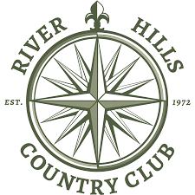
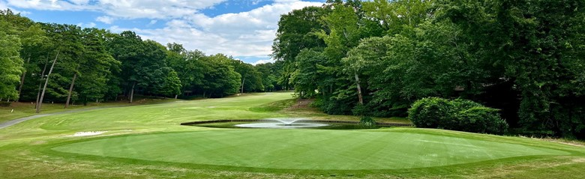
Secure Our Future
WITH CONCERT GOLF PARTNERS
The Board at RHCC has worked hard to ensure the long-term future of the club. Through years of creative financial strategies and prepayments from generous members, they’ve managed to maintain the daily operating budget and RHCC amenities. Now, you have material financial needs spanning most areas of the club. Capital, project management, experienced staff, and a clean balance sheet are required to elevate River Hills CC and lock in a bright future for generations to come.

They’ve presented data learned through extensive diligence and are asking members to consider this recapitalization as a strong option and long-term solution. The club's debt will be paid off completely, and capital improvements will begin immediately without any assessments, ever again. Just show up and enjoy your club with no future financial uncertainty.
BENEFITS TO MEMBERS

Board-approved list of capital projects funded and professionally managed | Dues frozen for first year, with contractually limited increases thereafter
No member assessments, ever | Deep industry relationships with ability to attract and retain talented staff
All bank debt paid off immediately | Creation of a Member Advisory Board
Club remains fully private | Access to reciprocal network
Culture, activities & traditions remain intact | Enhanced service levels & member experience
A $7+ MILLION RECAPITALIZATION

Concert Golf Partners will provide a capital infusion of more than $7.0 million dollars to pay off the club's debt, fund capital projects, update aging infrastructure, and address any of the working capital needs of the club. CGP has worked with the Board to identify specific capital improvement projects, which will begin within the first few months and be complete within 36 months. Projects will include:

- Rebuilding bunkers, addressing steepness, and improving playability
- Adding forward tee boxes and improving/expanding others per J. Lawrence designs
- Repairing and re-paving cart paths and tree root removal
- Dramatically improving drainage on numerous holes
- Clubhouse renovation to add all-weather dining, expand venue space for larger social functions, and expanding/upgrading the kitchen for increased functionality
- Refresh of the pool area with new furniture, cabanas, and aesthetics
- Major renovation to racquet surfaces, irrigation, fencing, wind shades, paint, beautification
- Leveling and resurfacing all parking areas; adding additional space for cars/cart

An additional 3-4 percent of revenue will be allocated to fund reserves for future capital projects on an average annual basis. Our investment is continuous.

ABOUT CONCERT GOLF PARTNERS

With a strong track record operating upscale golf clubs dating back 14 years, Concert Golf Partners has proven its boutique approach is a success. Members at current clubs routinely cite improved course conditions, fresh menus and execution, elevated service levels, and continuous upgrades to amenities.

Concert Golf Partners is a leading private club owner-operators in the US, with more than 5,000 employees across the country. CGP is a well-capitalized club hospitality company that is excited to provide a secure long-term future for River Hills Country Club.

Successful Approach

Network of industry experts with plenty of experience | Upscale private clubs are their ONLY business
Operation discipline – no other agendas | Patient, long-term capital

Experience

Concert Golf Partners owns and operates exclusively upscale private golf clubs – including Heathrow Country Club (Lake Mary, FL), MacGregor Downs Country Club (Raleigh, NC), and The Club at 12 Oaks (Raleigh, NC) – to name a few.
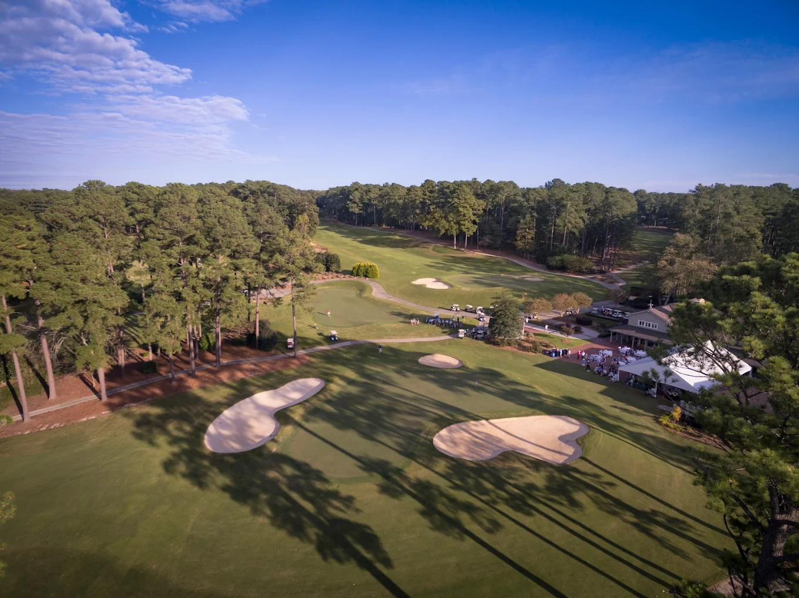
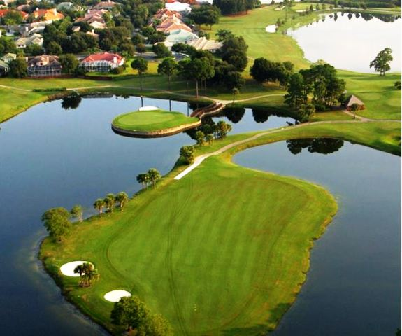

“We’ve kept our culture and personality that made Heathrow special. Almost 15 years after our recapitalization, the club has never looked better.”

-Former Board President at Heathrow Country Club
“Great progress is being made at our historically member-owned club since we voted to recapitalize the club with Concert Golf. Even the doubters are now believers.”

-Former Board Member, MacGregor Downs Country Club

Vote to secure River Hills Country Club’s future.
Visit www.ConcertGolfPartners.com.

